1. Manual Ledger Transactions
   1. Go to DailyTreasury/LedgerTransactionsEditor.aspx
   2. Specify transaction details
      1. Debtor and Creditor accounts
      2. Currency and Amount
      3. Specify other info and save

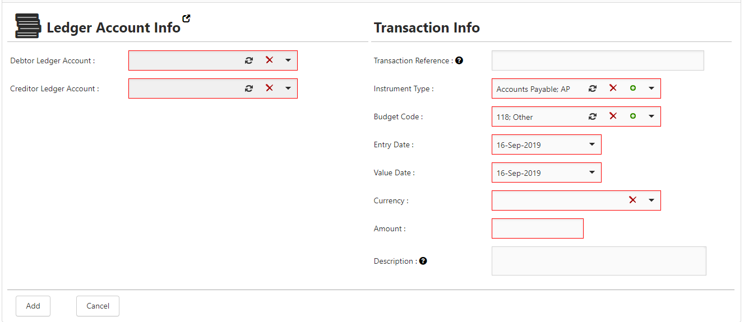

* + 1. Two entries will be added to the list of ledger transactions (One debit and one credit)



* 1. Go to DailyTreasury/LedgerTransactions.aspx
  2. Generate ledger transactions report for the transaction’s date (value date)

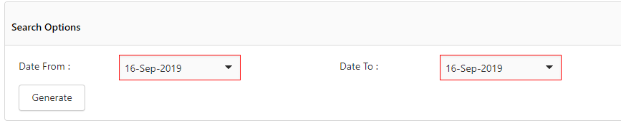

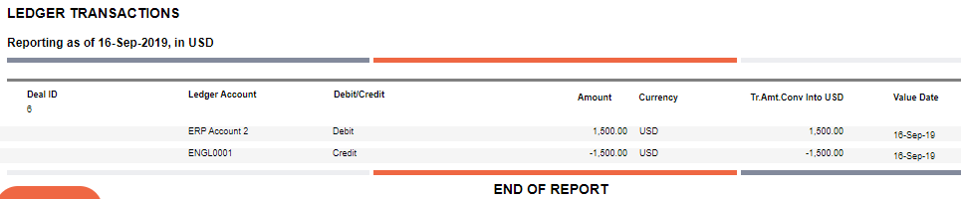

1. Auto Generate Ledger Transactions
   1. Define the account that transaction will be linked to. Go to Ledger accounts, create new Ledger account and link it to the bank transaction account

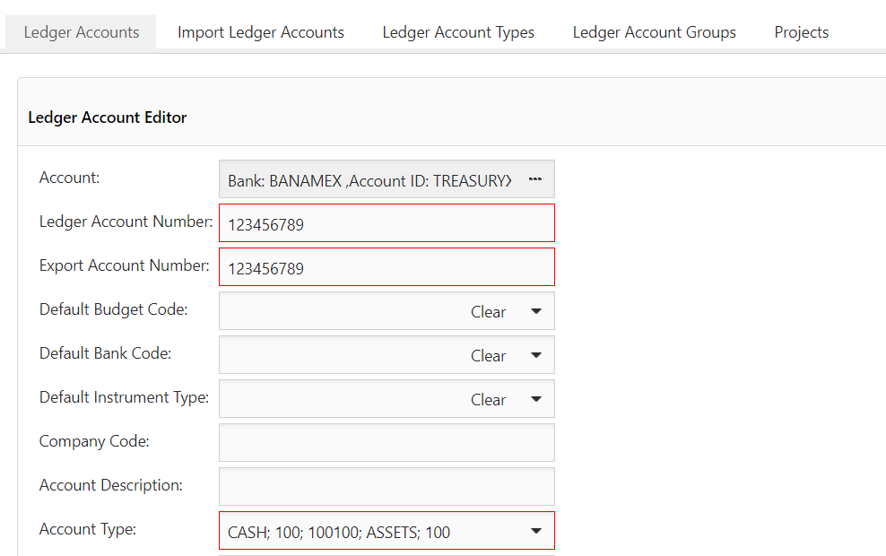

* 1. Then go to reconciliation rule / forecast auto generation and reconciliation. Create a new rule for the bank transaction account and select the ledger account

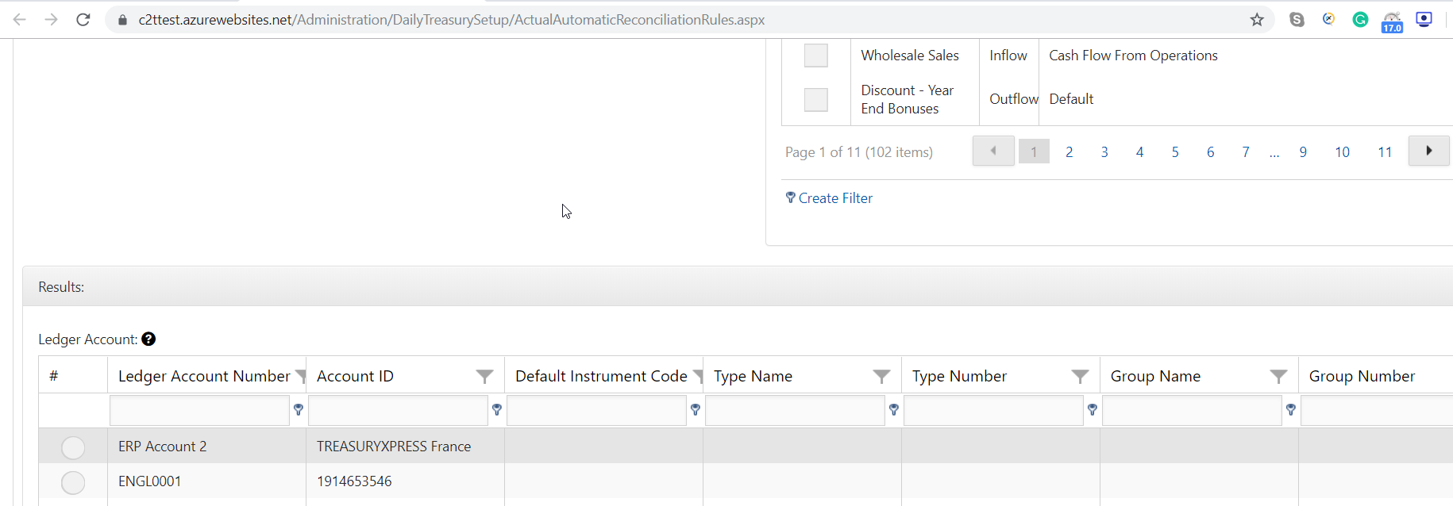

* 1. Create forecast transaction for the bank account number that a rule was added to it
  2. Import bank statement having the bank account number with transaction matching the forecast transaction added previously
  3. Go to reconciled statements
  4. Select the reconciled transaction

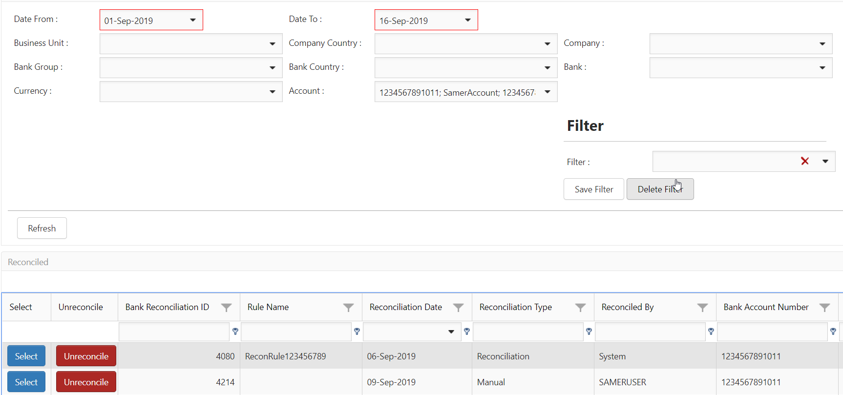

* 1. Select the reconciled transaction and go to the bottom of the page to Ledger Transactions

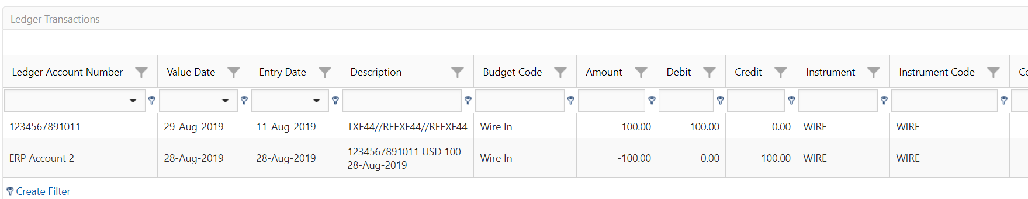

1. Reverse or void (remove) ledger transactions
   1. Select the reconciled transaction



* 1. Select Un-reconcile option



* 1. Select Unreconcile (Reverse accounting entries), confirm it
  2. Go to Ledger Transactions editors
  3. Reversal transaction entries will be available